**NAME: JULIANA BINTI SEMAN**

**STUDENT NO. P145688**

**SUBJECT: STQD 6114 – TEST2**

**SEMESTER : 2- 2025/2026**

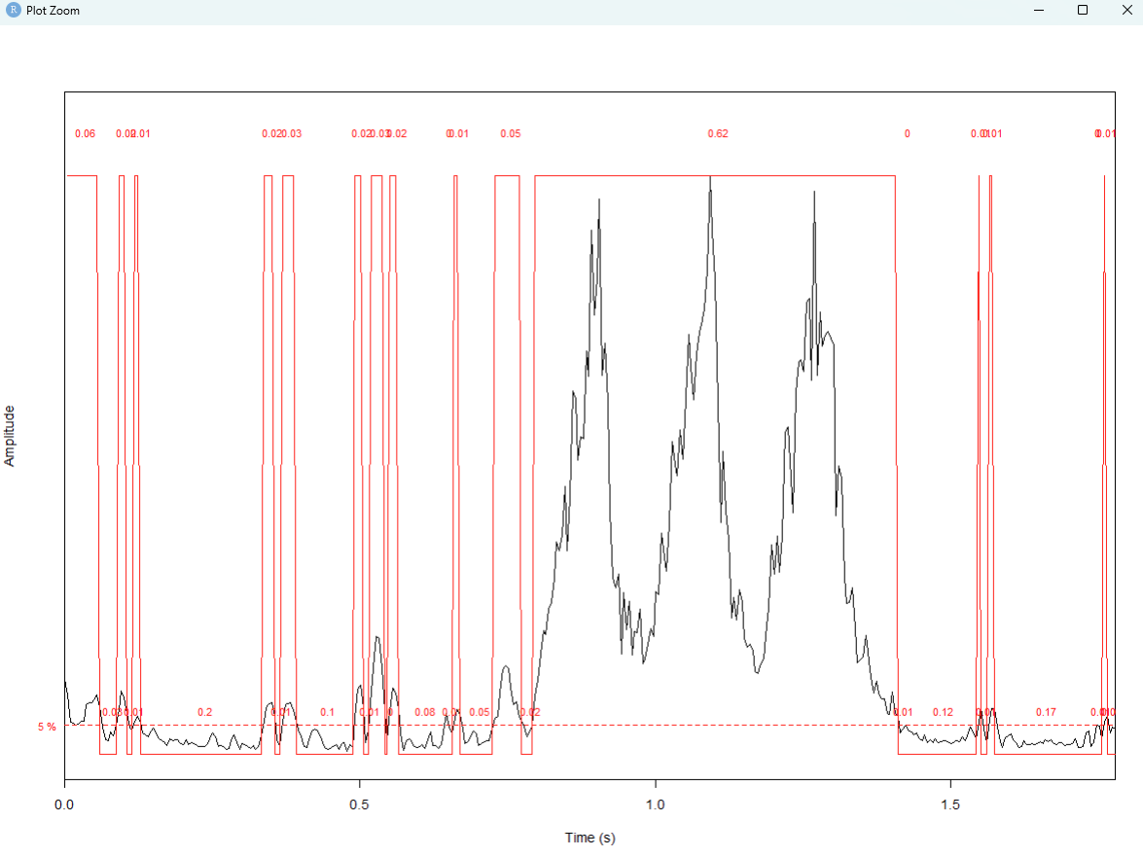

1. timer(z, f=22050, threshold=5, msmooth=c(100,0))

**Explanations:**

At sample 22050, with threshold 5, timer(): shows when the signal starts and ends clearly.

It has high frequency and high amplitude.

1. Spectogram

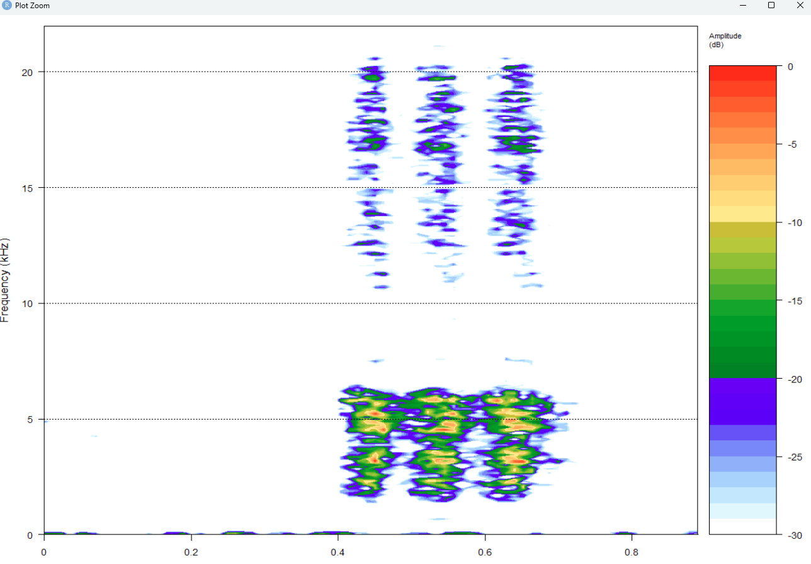

(c) Zk <- fft(z@left)

plot.frequency.spectrum(Zk)

plot.frequency.spectrum(Zk[1:20000])

1. Frequency Spectrum

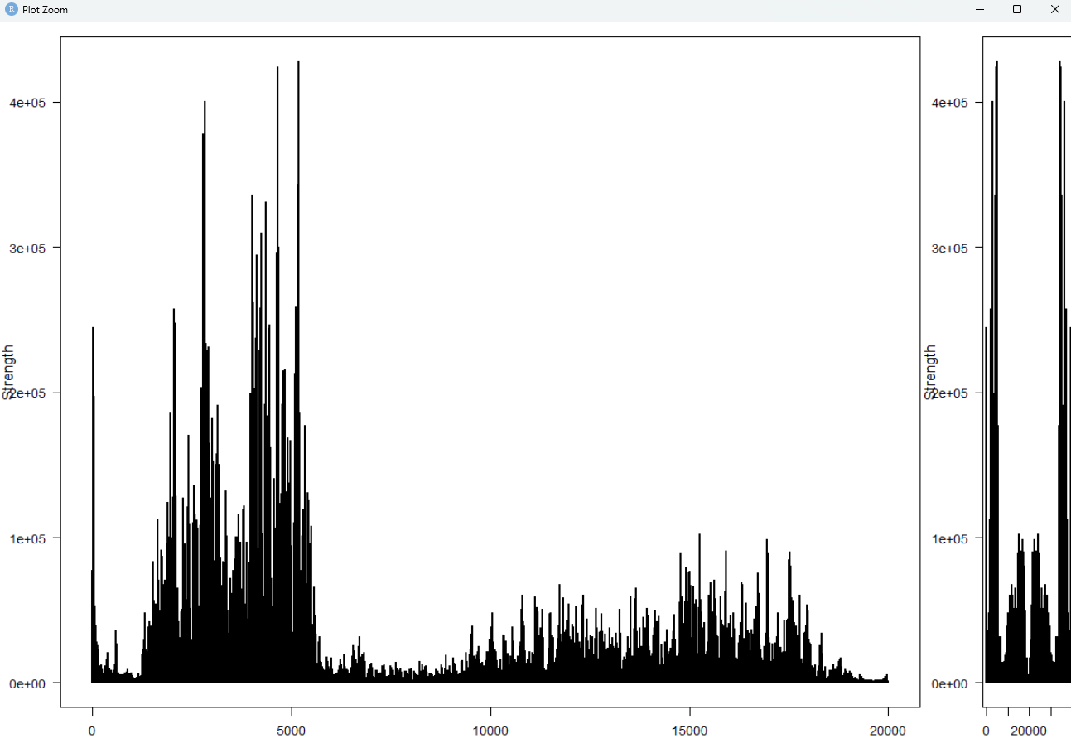

**Discuss:**

From the graph, it can be summarized that there is a high frequency and strength for the first sample of 5000, then later drops, then at sample of 10000, it starts to increase again but gradually and it the amplitude is low.